Time Signatures in Barry’s Piano Quartet
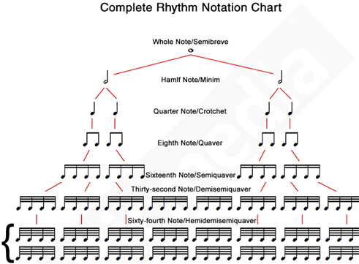
Top number tells how many beats are in each bar. Bottom number tells what kind of beat.
3/2 means 3 minim beats in each bar
3/4 means 3 crotchet beats in each bar
3/8 means 3 quaver beats in each bar
3/16 means 3 semi quaver beats in each bar
1/8
3/16
2/8
3/8
5/16
3/2
2/2
3/4
2/4

- When faced with a dotted rhythm, the dot cancels out the extra tail.
- Also note that 4/4 and 2/2 can look the same. Consider the overall context.
- A triplet is 2 notes played in the time of 2.
Study the sections below, D1 (Beidh Aonach Amárach) for Viola and Cello. Note the clefs as an extra.
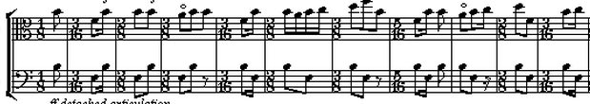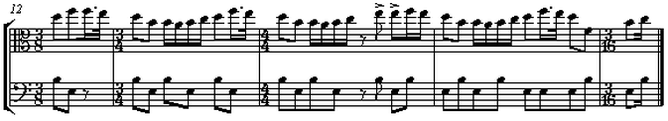

Section B
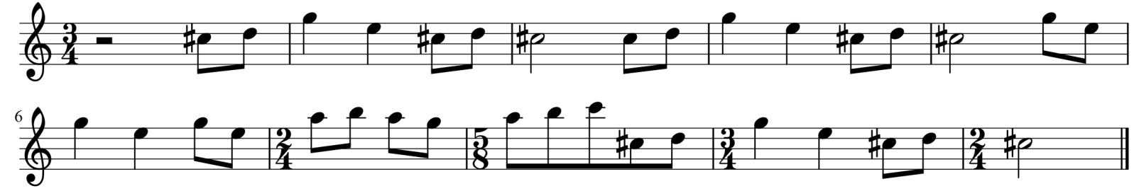

Section C
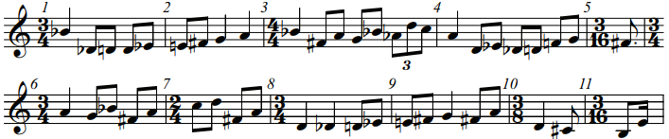

Add time signatures where necessary.
Bars 1,2 and 3
Bars 2,4 and 5
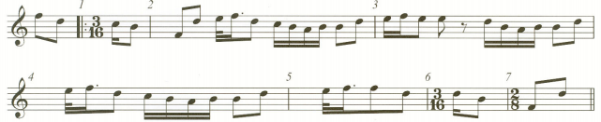
Bars X and Y
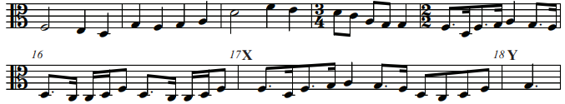
Bars 3,4 and 5
Bars 3 and 4
Bars 6 and 7
